Hand gestures



In this project you will train the computer to recognize different gestures you can make with your hands.

You will assemble a collection of different machine learning models so that they can work together to identify the shape of your hand in the webcam.

This project worksheet is licensed under a Creative Commons Attribution Non-Commercial Share-Alike License

http://creativecommons.org/licenses/by-nc-sa/4.0/

In this project, you will use pre-trained machine learning models that have been trained to find your hand in a view from your webcam.

These pre-trained models will give you the x,y coordinates of your wrist, and the top and bottom of each of your fingers.

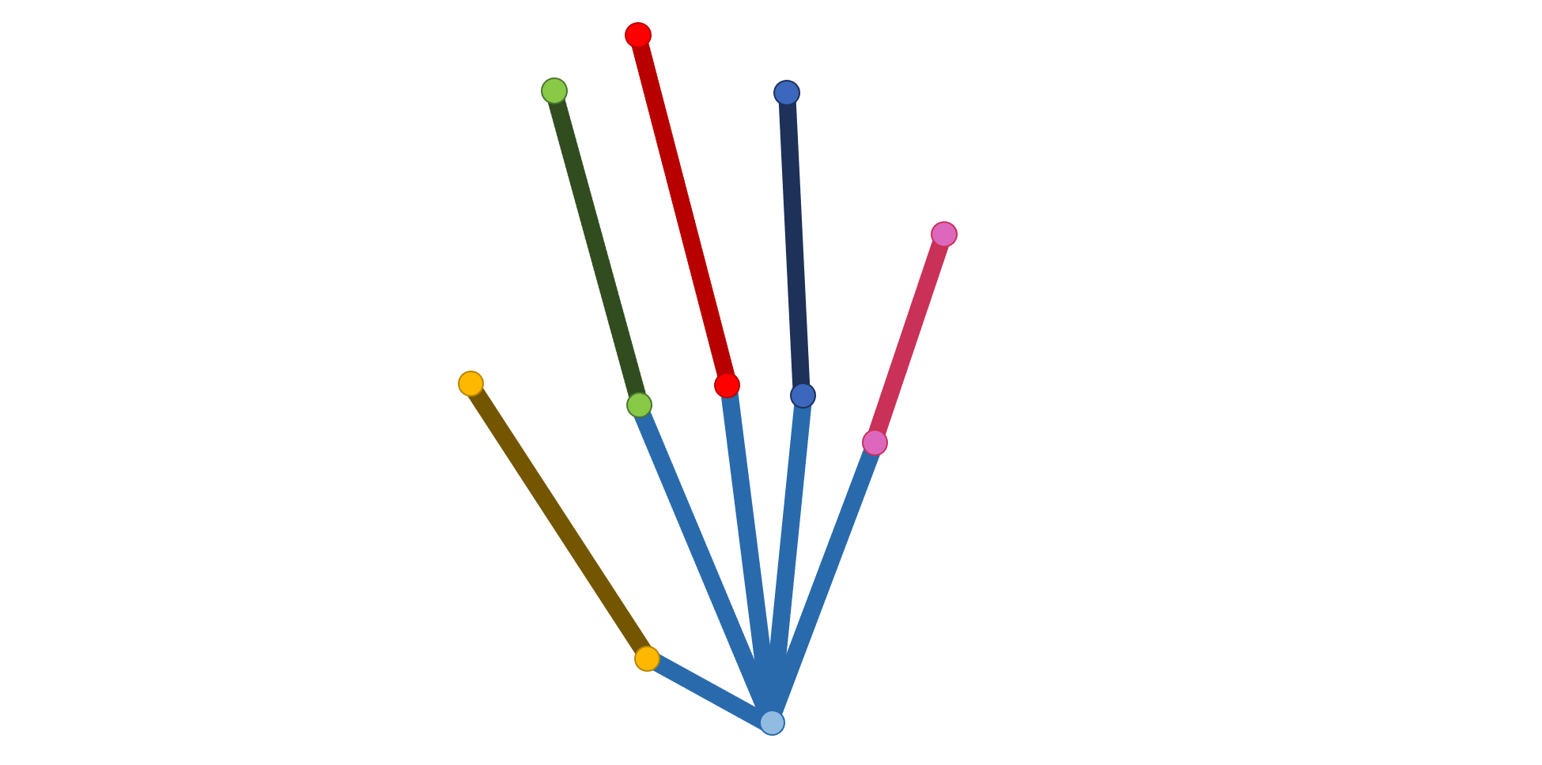

For example:

|  |  |  |  |  |  |  |  |  |
| --- | --- | --- | --- | --- | --- | --- | --- | --- |
|  |  | x | y |  |  | x | y |  |
|  | top of thumb | -82 | 2 |  | top of ring finger | 51 | 107 |  |
|  | base of thumb | -31 | -107 |  | base of ring finger | 39 | -23 |  |
|  | top of index finger | -45 | 119 |  | top of pinky finger | 110 | 45 |  |
|  | base of index finger | -25 | -11 |  | base of pinky finger | 66 | -46 |  |
|  | top of middle finger | -2 | 138 |  | wrist | 17 | -121 |  |
|  | base of middle finger | 9 | -11 |  |  |  |  |  |

You will use these coordinates to see if your computer can learn to recognize different hand gestures, based on the coordinates of your fingers when you make those gestures.

For example:

|  |  |  |
| --- | --- | --- |
|  |  |  |
| fist | okay | point |

Let’s start by trying out the pre-trained models to see what they can do.

1. Go to <https://machinelearningforkids.co.uk/> in a web browser
2. Click on “**Pretrained**”  
   Graphical user interface, text, application

   Description automatically generated
3. Click on “**Get started**”  
   Graphical user interface, text, application

   Description automatically generated
4. Click on “**Project templates**”  
   Graphical user interface, application, Teams

   Description automatically generated
5. Click on the “**Hand gestures**” template
6. Click on the **Green Flag**  
   *There might be a short delay while the machine learning model loads*
7. Hold **one** hand up to your webcam
8. Try ticking variables to see the values that the model gives you  
   *Move your hand in the webcam to see how the numbers change*  
   A picture containing graphical user interface

   Description automatically generated

These are the numbers that you will get the computer to learn from to recognize different hand shapes and gestures.

Next, you’ll prepare somewhere to collect these numbers as training examples.

1. Close the Scratch window   
   *Go back to* [*https://machinelearningforkids.co.uk*](https://machinelearningforkids.co.uk/)
2. Click on “**Log In**”  
   Graphical user interface, application, Teams

   Description automatically generated
3. Click on “**Try it now**”
4. Click the **“Copy template**” button  
   Graphical user interface, application

   Description automatically generated
5. Click the “**Hand gestures**” template, then click the “**Import**” button  
   Graphical user interface, text, application, Teams

   Description automatically generated  
     
   To make your Scratch coding simpler, we’ll just be using the coordinates for two of your fingers. That will still give you ten numbers to use in your code!  
     
   Chart

   Description automatically generated
6. You should see “**Hand gestures**” in your list of projects. Click on it.
7. Click the **Train** button.   
   Graphical user interface, text, application, website

   Description automatically generated
8. Click on “**+ Add new label**”  
   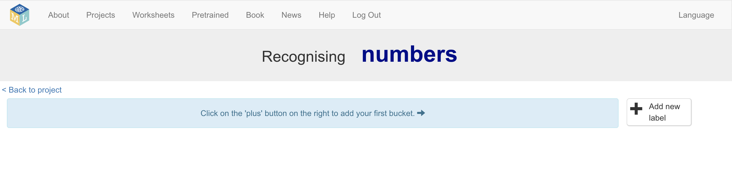
9. Type in “**fist**” and then click on “**Add**”.   
   Graphical user interface, application, Teams

   Description automatically generated
10. Do that again to create a second bucket called “**okay**”.  
    Do that a third time to create a bucket called “**point**”.  
      
    *If you use different hand-gestures for your project, choose hand-shapes that can be recognised from the two fingers we’re using (thumb and index finger).*  
    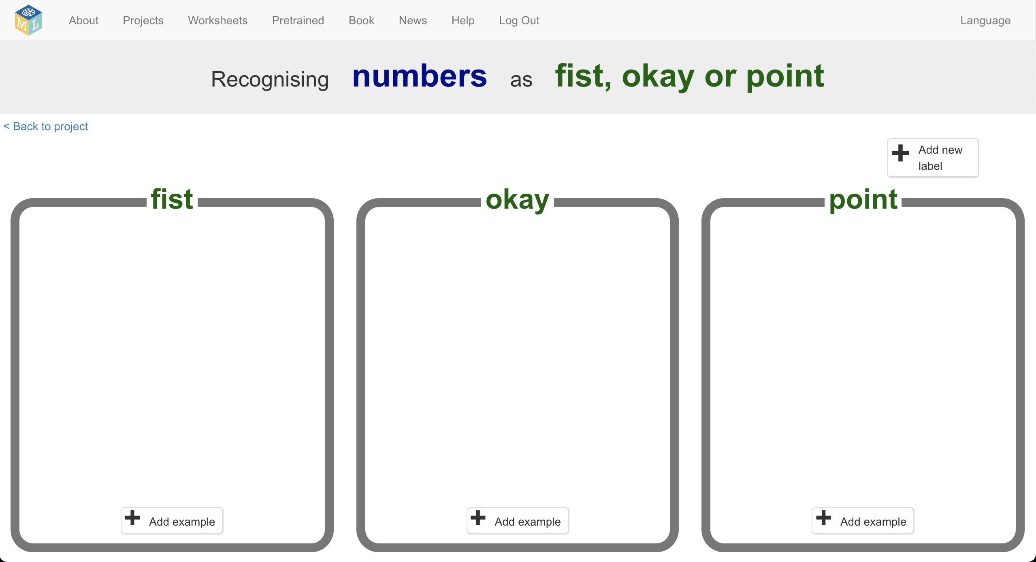

These are where you store training examples for the computer to learn from.  
  
Next, you’ll use Scratch to collect some examples.

1. Click on the **“< Back to project**” link
2. Click on the “**Make**” button
3. Click on the “**Scratch 3**” button
4. Click on the “**straight into Scratch**” button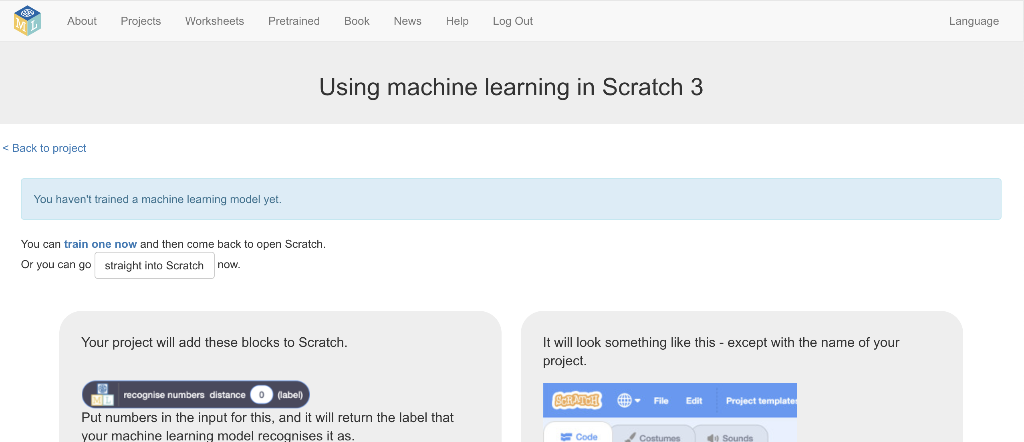
5. Click on “**Project templates**” (as you did before)  
   *The difference is that this time you will have extra blocks to use for your machine learning buckets.*
6. Click on the “**Hand gestures**” template (as you did before)
7. Find the placeholder for the “**store training data**” script   
   *You should find it on the sprite called “main”*  
   Graphical user interface, text, application, chat or text message

   Description automatically generated
8. Add a block from your machine learning project to store examples  
   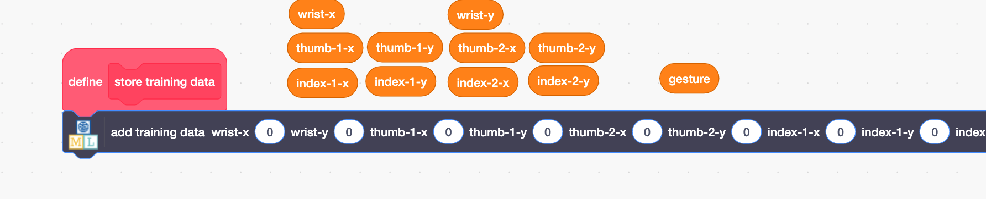
9. Copy in the orange variable blocks into the matching spaces on the “add training data” block  
   *Do this slowly and carefully!   
   There are a lot of blocks to add. (This is why we’re only using ten numbers for this project instead of all twenty-two)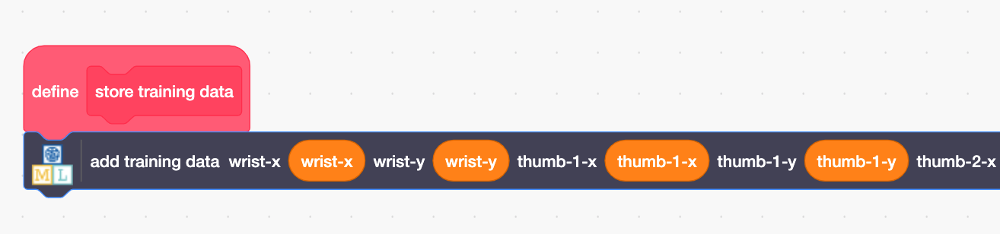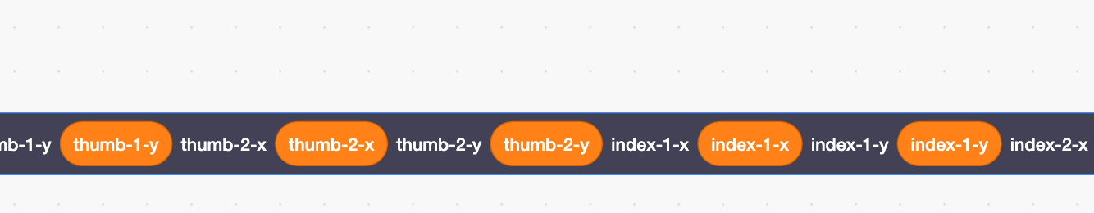 Don’t forget to use the gesture block for the last menu space.*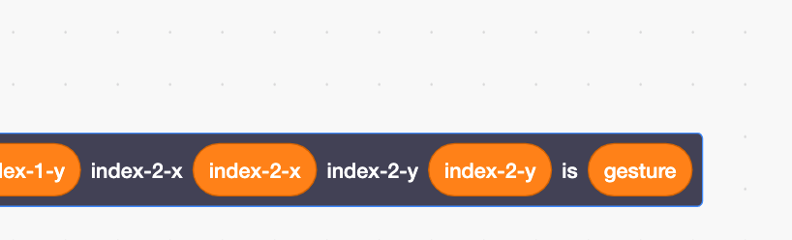
10. Create a script to collect a training example for your first gesture  
    *I’ve used the “f” key because “fist” starts with f. If you’re using different hand gestures for your project, you could pick a different key.*   
    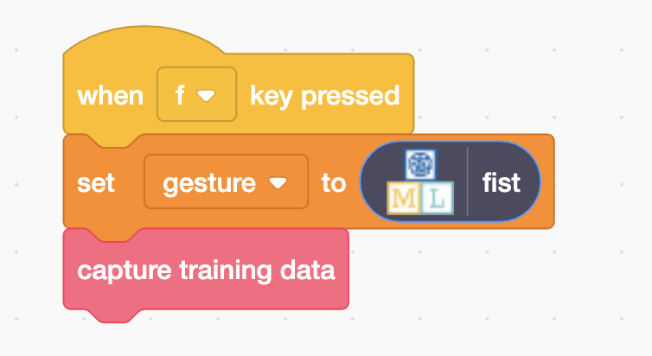
11. Create similar scripts for your other hand gestures  
    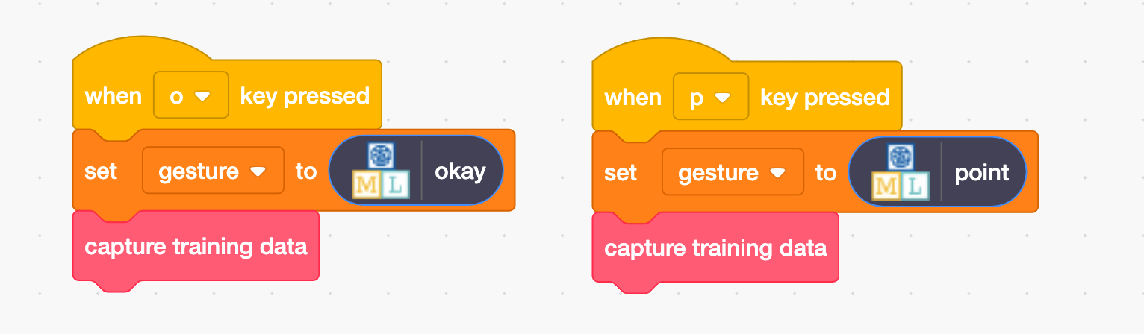

It’s time to collect some training examples.

1. Click the **full-screen** button  
   Graphical user interface, application

   Description automatically generated
2. Click on the **Green Flag**
3. Make your hand into the shape of a fist (or your first gesture) in the webcam, and wait until you think the dots have correctly found your hand  
   *It works better if only one of your hands is visible in the webcam.*
4. Press the **F** button on your keyboard  
   *(Or whichever key you picked for your first gesture.)  
   The dots stay still while coordinates are added to the “fist” training bucket*
5. Repeat steps 32-33 **nine** more times  
   *Try to vary the position of your hand in the webcam (for example, get some examples with your hand on the left side, and some on the right side) and vary how close your hand is to the webcam in each example.*
6. Check the training tool page where you created the buckets to see the examples you’ve collected  
   *Click on the “****< Back to project****” link and then click on “****Train****”  
   (Don’t close the Scratch window!)*A picture containing rectangle

   Description automatically generated
7. Go back to the Scratch window
8. Collect training examples for your second hand gesture  
   *As before, use your Scratch project but this time press the* ***O*** *key on your keyboard while making an “okay” gesture (see page 2 for an example).   
   Collect* ***ten*** *training**examples of this hand shape.*   
   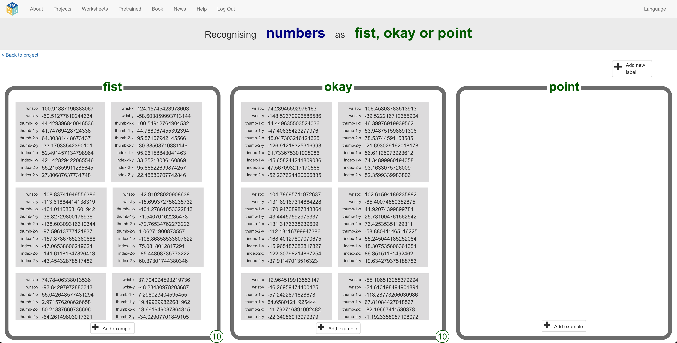
9. Repeat for your final hand gesture  
   *Use the* ***P*** *key to collect examples while pointing (see page 2 for example)  
   As before, try to get a variety of locations (where your hand is in the screen) and sizes (how close your hand is to the webcam) in your training examples.  
   Text

   Description automatically generated*

You’ve collected enough training examples to get started.

Next, you’ll get the computer to learn to recognize hand gestures by using these examples to train a machine learning model.

1. In the training tool window, click on the “**< Back to project**” link  
   *Leave the Scratch window open, as you’ll be using it again in a moment.*
2. Click on the “**Learn & Test**” button  
   Graphical user interface, text, application, website

   Description automatically generated
3. Click on the “**Train new machine learning**” button  
   Graphical user interface, text, application

   Description automatically generated
4. Go back to the Scratch window
5. Click on the full-screen button so you can see the code again
6. Find the placeholder for the “**recognise gesture**” script  
   *It is also in the sprite called “main”, above the code you worked on before.*Graphical user interface

   Description automatically generated
7. Drag a “**recognise numbers … (label)**” block into the gap with ???  
   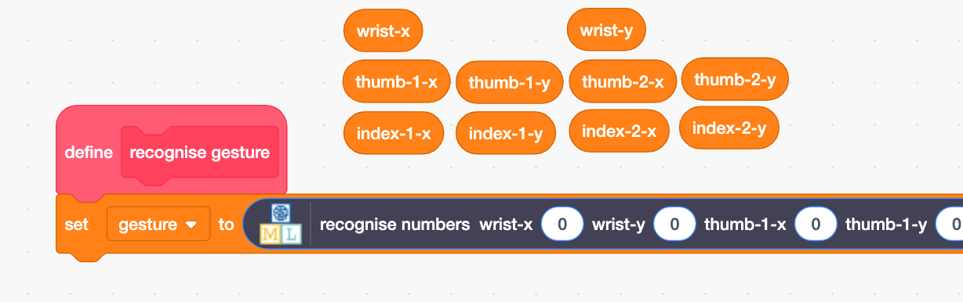
8. Copy in the orange variable blocks into the matching spaces on the “recognise numbers” block  
   *Do this slowly and carefully!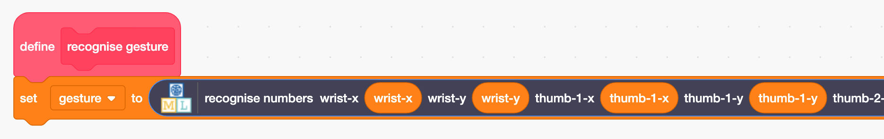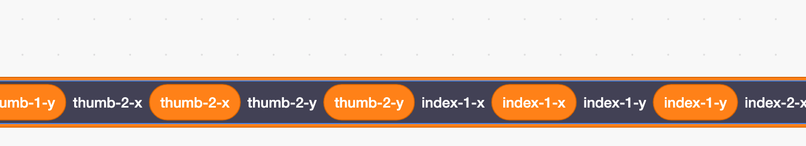 Make sure you are using the “(label)” block,* ***not*** *the “(confidence)” block.*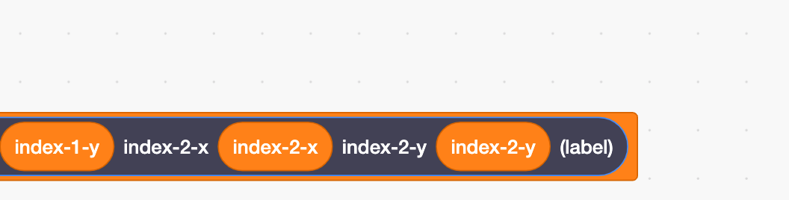

Your project is now ready to go. It is time to test your machine learning model!

1. Click the **full-screen** button
2. Click on the **Green Flag**
3. Make one of your gestures and hold your hand in front of the webcam, and wait until you think the dots have correctly found your hand
4. Press the **space bar** on your keyboard  
   *The machine learning model’s prediction will be displayed in the top-left.*

Does your machine learning model correctly recognize your hand gestures?  
  
You might find that, with only ten examples of each shape, the model is still making mistakes.   
If so, **repeat steps 31-42** (to collect twenty examples of each gesture and then train a new, improved machine learning model).

**What have you done so far?**

You’ve used a combination of different machine learning models (two pre-trained models, and one new custom model that you trained yourself) to make an artificial intelligence project that can do something new: recognize your hand gestures.

Instead of using a combination of machine learning models in this way, you could have just trained one new image machine learning model to recognize your hand shapes.

(If you’d like to see how that approach works, you can try the “Rock, Paper, Scissors” worksheet which uses this technique.)

Why do you think the technique you used in this project might be better?

|  |  |  |  |
| --- | --- | --- | --- |
| **Input** | **Model** | **Training challenge** | **Output** |
| picture of anything that includes a hand somewhere | Hand detection | Difficult  Creating this model will involve a lot of training data with a large range of backgrounds (different types of indoors rooms, outdoor scenes and environments, etc.), with a variety of hands (different sizes, colours, etc.), in different positions  Doing this is a lot of work! | location of something that looks like a hand |
| picture of a hand | Landmark detection | Difficult  Creating this model will involve training data with a variety of hands in a variety of positions.  Doing this is a lot of work! | Shape  Description automatically generated  location of finger joints |
| Shape  Description automatically generated  coordinates of finger joints | Gesture recognition | Simple  Creating this model will involves recognizing relationship between a small collection of numbers.  It doesn’t need to deal with different backgrounds, or colours, or shadows, etc.  This can be done with a small amount of training data. | “okay” |

The table on the previous page describes what you did for this project.

Three machine learning models were used:

* A pre-trained hand detection model
* A pre-trained hand landmark detection model
* A custom gesture recognition model that you trained yourself

This is a common approach to machine learning projects:

1) break the overall thing that you want the project to do into separate steps

2) use pre-trained models for the steps that are common tasks

Tasks that other people have wanted to do (e.g. find a hand)

Tasks that other people have spent time and effort to train a machine learning model for  
 Tasks that aren’t particularly unique to your project

3) train a new custom model for the steps that are unique to your project

Doing all of this in a single model means that your model has to learn how to do all of these separate steps by itself.

|  |  |  |  |
| --- | --- | --- | --- |
| **Input** | **Model** | **Training challenge** | **Output** |
| A picture containing text, person, indoor  Description automatically generated  picture of anything that includes a hand somewhere | Hand detection | Very difficult  This model needs to recognize a variety of hands (different sizes, colours, etc.) in a variety of locations, when seen against a large range of backgrounds (different types of indoors rooms, outdoor scenes and environments, etc.), and making a variety of shapes/gestures.  That is a lot of things for one model to learn, so a lot of training examples will be needed. | “okay” |

But if you only use pre-trained models, then this limits you to only being able to make AI projects that someone else has already thought of.

**What have you done?**

You’ve seen how artificial intelligence projects can combine pre-trained models with custom models to get the best of both worlds: the extensive training data and accuracy of pre-trained models, and ability to make new and unique models for new project ideas.

**Ideas and Extensions**

Now that you’ve finished, why not give one of these ideas a try?

Or come up with one of your own?

**Try different hand gestures**

Try making the project with your own ideas for hand gestures.

**Try using an images model**

Try making this project using a single, custom, images machine learning model. Which technique is easier for you to train? Which approach do you think works the best?

**Use different finger coordinates**

Instead of using locations for your wrist, thumb and index fingers, you could create the numbers project yourself and choose the number fields that you want to use.

Do you think you need the coordinates for the tip of each finger **and** the base of each finger? Would just the locations of fingertips be good enough?

Think about the hand shapes you want the computer to recognize and try making a project based on the values you think would best help the machine to know what hand shape you are making.